Answer to Objective Questions   
 Submitted by Tanupriya *Awasthi*

**1. List the different dtypes of columns in table “ball_by_ball” (using information schema)**

**Ans.** As per the schema, all the columns are declared with integer data type that means all the values are expected to be in numeric whole number.

|  |  |
| --- | --- |
| Column Name | Data type |
| Match_Id | integer |
| Over_Id | integer |
| Ball_Id | integer |
| Innings_No | integer |
| Team_Batting | integer |
| Team_Bowling | integer |
| Striker_Batting_Position | integer |
| Striker | integer |
| Non_Striker | integer |
| Bowler | integer |

**2. What is the total number of run scored in 1st season by RCB (bonus: also include the extra runs using the extra runs table)**

**Ans.** The total runs scored byRCB in 1st season are 1241592 which also include the extra runs.

**Query:   
select sum(Runs_Scored+Extra_Runs) as total_runs  
from batsman_scored b  
join extra_runs e on b.Match_Id=e.Match_Id  
join player_match pm on b.Match_Id = pm.Match_Id  
join matches m on e.Match_Id = m.Match_ID  
where m.Season_Id =1 and pm.Team_Id =2;**

**3.How many players were more than age of 25 during season 2 ?**

**Ans. There were** 162 players which were more than age of 25 during season 2 which was in 2009.

**Strategy:** First looked when the season 2 was held then calculated the age of players in that year and then filtered the players whose age was greater than 25.

**with player_age as   
(select *,Timestampdiff(Year,DOB,'2009-01-01') as AGE  
from player)  
select count(*) as no_of_players_Season2  
from player_age  
where AGE>25;**

**4. How many matches did RCB win in season 1 ?**

**Ans.** RCB won **4 matches** in season 1.

**Strategy:** For this we used matches table where we applied the filter for season 1 and match winner as 2 because the team ID for RCB is 2.

**select count(*) from matches  
where Season_Id = 1 and Match_Winner = 2;**

**5. List top 10 players according to their strike rate in last 4 seasons?**

**Ans.** The below listed chart shows the top 10 players according to their strike rate in the last 4 season.

**6. What is the average run scored by each batsman considering all the seasons?  
Ans.** The below listed are some of the batsman with average runs scored considering all the seasons. For the full list kindly refer to the query below:

|  |  |
| --- | --- |
| Player Name | Avg. Runs |
| A Ashish Reddy | 282.32 |
| A Chandila | 284.08 |
| A Chopra | 241.29 |
| A Flintoff | 300.00 |
| A Kumble | 276.83 |
| A Mishra | 283.56 |
| A Mithun | 288.56 |
| A Mukund | 331.00 |

**Strategy:** For thisfirst we have joined the tables which contain the data like players name, runs scored. Then we have calculated the number of matches played and the total runs scored and on the basis which we have calculated the average runs by each batsman.  
 **Query:  
select p.Player_Name, round(sum(Runs_Scored)/Count(distinct m.Match_Id), 2) as avg_runs   
from batsman_scored b  
join player_match pm on b.Match_Id = pm.Match_Id  
join player p on pm.Player_Id = p.Player_Id  
join matches m on b.Match_Id = m.Match_ID  
group by 1;**

**7. What are the average wickets taken by each bowler considering all the seasons?  
Ans:** The below listed are some of the bowlers with average wickets taken considering all the seasons. For the full list kindly refer to the query below:

|  |  |
| --- | --- |
| Players Name | Average Wickets |
| A Ashish Reddy | 15 |
| A Chandila | 14.33 |
| A Chopra | 14.2 |
| A Flintoff | 14.14 |
| A Kumble | 14 |
| A Mishra | 13.54 |
| A Mithun | 13.4 |
| A Mukund | 13.33 |
| A Nehra | 13.14 |
| A Nel | 13.07 |
| A Singh | 13 |
| A Symonds | 13 |

**Query :**  
**select p.Player_Name , round(count(Player_Out)/Count(distinct m.Match_Id),2) as avg_wicket from wicket_taken w  
join player_match pm on w.Match_Id=pm.Match_Id  
join player p on pm.Player_Id=p.Player_Id  
join matches m on w.Match_Id=m.Match_Id  
group by 1;**

**8. List all the players who have average runs scored greater than overall average and who have taken wickets greater than overall average  
Ans.** With the help of the below written query we can get the player id of all the players who have average runs scored greater than overall average and who have taken wickets greater than overall average.

**Query:  
WITH overall_averages AS (  
SELECT AVG(Runs_Scored) AS overall_avg_runs,AVG(Player_Out) AS overall_avg_wickets  
FROM batsman_scored   
join wicket_taken using (Match_Id)),**

**player_stats as (  
select Player_Id round(count(Player_Out)/Count(distinct m.Match_Id),2) as avg_wicket, avg(Runs_Scored) as avg_runs_scored  
from wicket_taken  
join batsman_scored using(Match_Id)  
join player_match using(Match_Id)  
group by 1)**

**Select Player_Id,avg_runs_scored,overall_avg_runs,avg_wickets,overall_avg_wickets  
from overall_averages oa  
join player_stats ps   
ON ps.avg_runs_scored > oa.overall_avg_runs   
AND ps.avg_wickets > oa.overall_avg_wickets;**

**9. Create a table rcb_record table that shows wins and losses of RCB in an individual venue.**

**Ans.**

**Query:  
Create table rcb_record (  
Venue_Id int primary key,  
Venue_name varchar(200),  
Wins int default 0,  
Losses int default 0);**

**insert into rcb_record (Venue_Id, Venue_name, Wins, Losses)  
Select Venue_Id , Venue_name,  
sum(case when Match_Winner=2 then 1 else 0 end) as Wins ,  
sum(case when(Match_Winner!=2 and (Team_1=2 or Team_2=2)) then 1 else 0 end) as Losses  
from matches  
join venue using(Venue_Id)  
where Team_1= 2 or Team_2=2  
group by 1,2;**

**10. What is the impact of bowling style on wickets taken.  
Ans.** From the below chart we can see the impact of bowling style. From this we can see that left arm fast bowlers take more wickets followed by left arm medium fast bowlers . We can say that left arm fast or medium fast bowlers have tendency to take more wickets compared to other bowler.

**11. Write the sql query to provide a status of whether the performance of the team better than the previous year performance on the basis of number of runs scored by the team in the season and number of wickets taken.**

**Query:**

**with team_performance as  
(select m.Season_Id,t.Team_Name, sum(bs.Runs_Scored) as total_runs, sum(w.Player_Out) as total_wickets  
 from team t join matches m on t.Team_Id in (m.Team_1,m.Team_2)  
 left join ball_by_ball b on b.Match_Id=m.Match_Id and t.Team_Id=b.Team_Batting  
left join batsman_scored bs on bs.Match_Id=b.Match_Id and bs.Over_Id=b.Over_Id and bs.Ball_Id=b.Ball_Id and bs.Innings_No=b.Innings_No  
 left join wicket_taken w on w.Match_Id=b.Match_Id and w.Over_Id=b.Over_Id and w.Ball_Id=b.Ball_Id and w.Innings_No=b.Innings_No  
group by 1,2,3),**

**performance_comparison as (  
select Season_Id,Team_Name, total_runs,total_wickets, lag(total_runs) over(partition by Team_Id order by Season_Id) as prev_year_runs,  
lag(total_wickets) over(partition by Team_Id order by Season_Id)as prev_year_wickets   
from team_performance)**

**select Season_Id,Team_Name,total_runs, prev_year_runs,total_wickets,prev_year_wickets,   
case   
when total_runs > prev_year_runs and total_wickets > prev_year_wickets then 'Better'   
 when total_runs < prev_year_runs and total_wickets < prev_year_wickets then 'Poor'  
else 'Mixed’  
end as Performance_status from performance_comparison   
 where prev_year_runs is not null and prev_year_wickets is not null   
 order by Team_Name,Season_Id;**

**12. Can you derive more KPIs for the team strategy if possible?**

**Ans.** The more KPIs for the team strategy are :

**Bowling KPI –** Economy Rate, Average wickets per match, Dot balls, Power play runs, Death over runs

**Batting KPIs** – Strike Rate, Average runs per match, Boundary, Dot ball

We have compared the strike rate with previous year strike rate , wickets taken with previous etc. and calculate the performance status of the teams whether their performance is getting better every year or declining or its constant.

From these KPI the team should look for the openers who have a high strike rate and has the ability to score freely in the first 6 and 7 overs.

The team should focus on death bowling specialist who have a track record of low economy rate.

Can also look for players who have average or high strike as well as low economy rate.

**Query:** The more KPI can be the number of sixes and foursa player had number of dot balls he faced, strikr rate, average runs per match etc.

**WITH team_performance AS   
( SELECT m.Season_Id, t.Team_Id,t.Team_Name,   
 COUNT(DISTINCT m.Match_Id) AS matches_played,  
 COUNT(b.Innings_No) AS total_innings,   
 SUM(bs.Runs_Scored) AS total_runs,  
 COUNT(w.Player_Out) AS total_wickets,  
 SUM(CASE WHEN bs.Runs_Scored = 4 THEN 1 ELSE 0 END) AS fours,  
 SUM(CASE WHEN bs.Runs_Scored = 6 THEN 1 ELSE 0 END) AS sixes,   
 SUM(CASE WHEN bs.Runs_Scored = 0 THEN 1 ELSE 0 END) AS dot_balls,   
 COUNT(b.Ball_Id) AS balls_faced,  
 SUM(CASE WHEN b.Over_Id >= 16 THEN bs.Runs_Scored ELSE 0 END) AS Death_Over_Runs,  
 SUM(CASE WHEN b.Over_Id < 7 THEN bs.Runs_Scored ELSE 0 END) AS Powerplay_Runs,  
 COUNT(DISTINCT CASE WHEN m.Win_Type = t.Team_Id THEN m.Match_Id END) AS matches_won FROM team t   
JOIN matches m ON t.Team_Id IN (m.Team_1, m.Team_2)  
 LEFT JOIN ball_by_ball b ON b.Match_Id = m.Match_Id  
LEFT JOIN batsman_scored bs ON b.Match_Id = bs.Match_Id AND b.Over_Id = bs.Over_Id AND b.Ball_Id = bs.Ball_Id AND b.Innings_No = bs.Innings_No  
LEFT JOIN wicket_taken w ON w.Match_Id = b.Match_Id AND w.Over_Id = b.Over_Id AND w.Ball_Id = b.Ball_Id AND w.Innings_No = b.Innings_No  
GROUP BY 1, 2, 3),**

**performance_comparison AS (  
 SELECT Season_Id, Team_Id,Team_Name,matches_played,total_innings, total_runs, total_wickets,fours,sixes,dot_balls,balls_faced,matches_won, Death_Over_Runs, Powerplay_Runs,  
round((total_runs * 6.0) / balls_faced,2) AS Economy_Rate ,  
ROUND(total_runs*100/balls_faced , 2) AS strike_rate,  
ROUND(total_runs/matches_played, 2) AS avg_runs_per_match,  
ROUND(total_wickets/matches_played, 2) AS avg_wickets_per_match,  
 ROUND(dot_balls*100/matches_played , 2) AS dot_balls_percentage,  
 LAG(total_runs) OVER (PARTITION BY Team_Id ORDER BY Season_Id) AS prev_year_runs, LAG(total_wickets) OVER (PARTITION BY Team_Id ORDER BY Season_Id) AS prev_year_wickets, LAG(ROUND(total_runs/balls_faced, 2)) OVER (PARTITION BY Team_Id ORDER BY Season_Id) AS prev_year_strike_rate  
 FROM team_performance)**

**SELECT Season_Id, Team_Name, matches_played,total_runs,total_wickets,fours,sixes,strike_rate,avg_runs_per_match,avg_wickets_per_match, prev_year_runs, prev_year_wickets, prev_year_strike_rate, Death_Over_Runs, Powerplay_Runs,  
 CASE WHEN total_runs > prev_year_runs AND total_wickets > prev_year_wickets AND strike_rate > prev_year_strike_rate THEN 'Significantly Better'  
WHEN total_runs > prev_year_runs AND total_wickets > prev_year_wickets THEN 'Better'  
WHEN total_runs < prev_year_runs AND total_wickets < prev_year_wickets AND strike_rate < prev_year_strike_rate THEN 'Significantly Worse'  
 WHEN total_runs < prev_year_runs AND total_wickets < prev_year_wickets THEN 'Worse'  
WHEN strike_rate > prev_year_strike_rate THEN 'Improved strike_rate '  
ELSE 'Mixed'  
END AS performance_status   
FROM performance_comparison   
WHERE prev_year_runs IS NOT NULL AND prev_year_wickets IS NOT NULL   
ORDER BY Team_Name, Season_Id;**

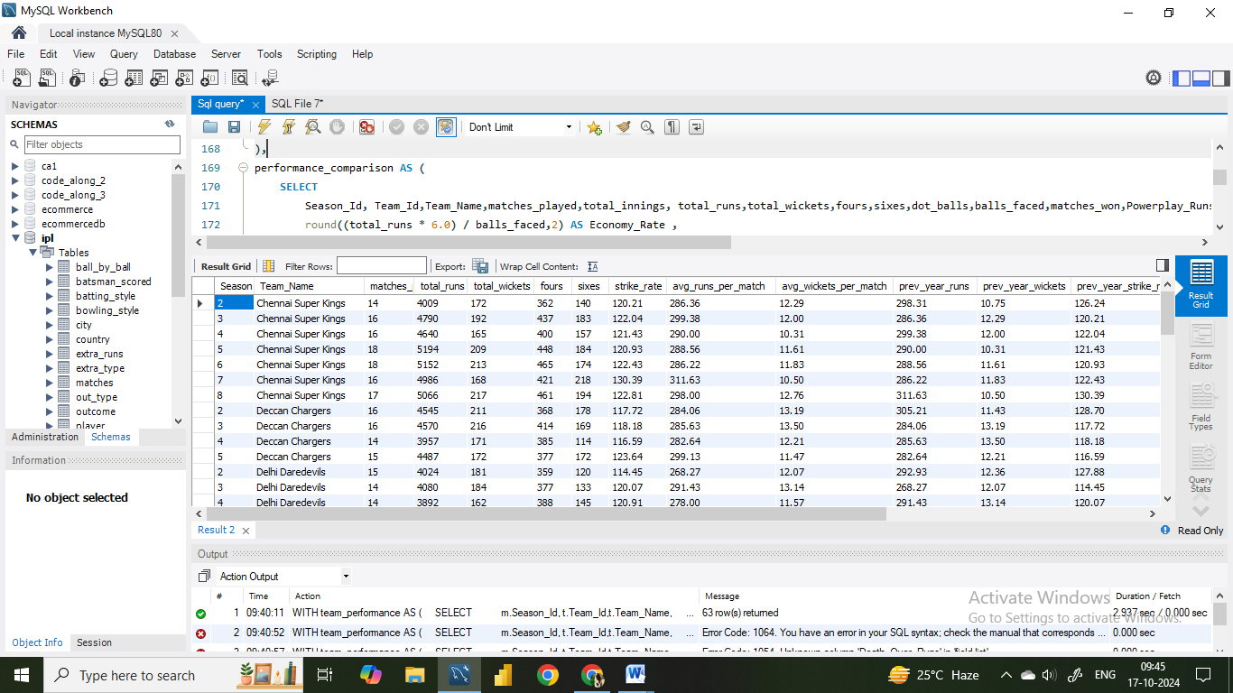

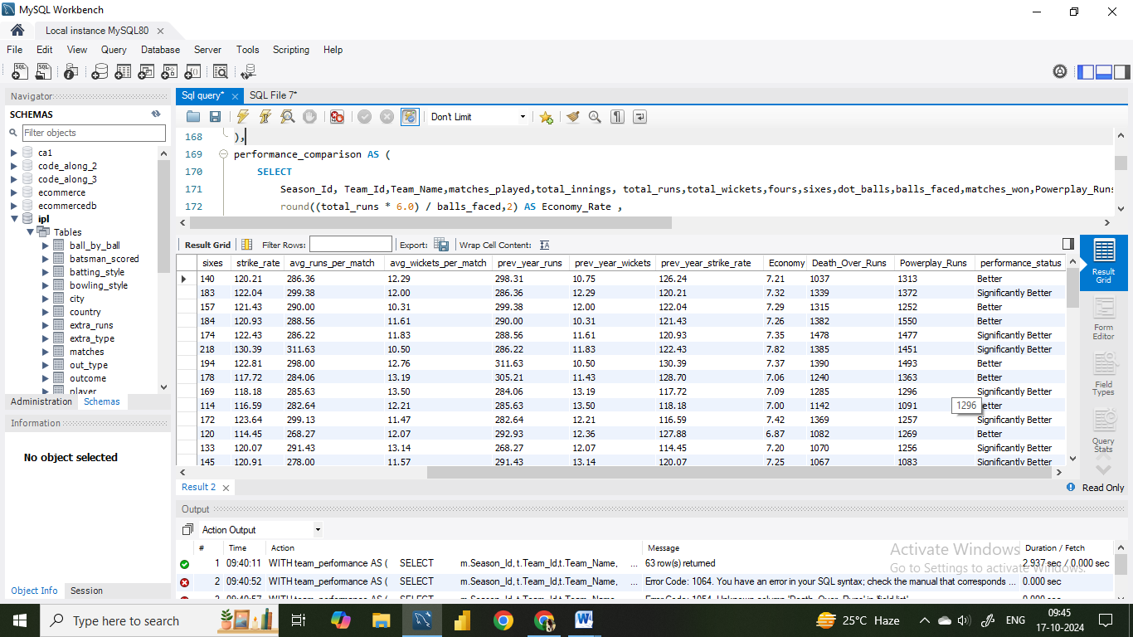

**13. Using SQL, write a query to find out average wickets taken by each bowler in each venue. Also rank the gender according to the average value.  
Ans.**

**Query:  
Select p.Player_Id,Player_Name,Venue_Name,Round(avg(Player_Out),2) as average_wickets,  
 dense_rank() over(partition by Venue_Name order by avg(Player_Out) desc) as `rank`  
from wicket_taken w  
join matches m on w.Match_Id=m.Match_Id  
join venue v on v.Venue_Id=m.Venue_Id  
join player_match pm on m.Match_Id=pm.Match_Id  
join player p on pm.Player_ID=p.Player_Id  
group by 1,2,3;**

**14. Which of the given players have consistently performed well in past seasons? (will you use any visualisation to solve the problem)**

**Ans.** The low standard deviation indicates that the players are consistent in their performance across the season.

|  |  |  |  |  |  |
| --- | --- | --- | --- | --- | --- |
| Player Id | Player Name | Min Runs | Max Runs | Avg Runs | Std dev |
| 460 | Mustafizur Rahman | 4704 | 4704 | 4704.0000 | 0 |
| 407 | JC Buttler | 4180 | 4180 | 4180.0000 | 0 |
| 118 | GD McGrath | 4101 | 4101 | 4101.0000 | 0 |
| 413 | KH Pandya | 3596 | 3596 | 3596.0000 | 0 |
| 49 | SM Pollock | 3557 | 3557 | 3557.0000 | 0 |
| 70 | Shahid Afridi | 3071 | 3071 | 3071.0000 | 0 |
| 102 | Sohail Tanvir | 3042 | 3042 | 3042.0000 | 0 |
| 319 | N Saini | 3012 | 3012 | 3012.0000 | 0 |
| 420 | RR Pant | 2949 | 2949 | 2949.0000 | 0 |
| 434 | CJ Jordan | 2939 | 2939 | 2939.0000 | 0 |
| 107 | SP Fleming | 2833 | 2833 | 2833.0000 | 0 |
| 418 | M Ashwin | 2811 | 2811 | 2811.0000 | 0 |
| 143 | DP Vijaykumar | 2793 | 2793 | 2793.0000 | 0 |
| 230 | AC Voges | 2597 | 2597 | 2597.0000 | 0 |
| 117 | Mohammad Asif | 2518 | 2518 | 2518.0000 | 0 |
| 326 | V Pratap Singh | 2500 | 2500 | 2500.0000 | 0 |
| 108 | S Vidyut | 2418 | 2418 | 2418.0000 | 0 |
| 353 | BJ Rohrer | 2397 | 2397 | 2397.0000 | 0 |
| 122 | M Ntini | 2395 | 2395 | 2395.0000 | 0 |

**15. Are there players whose performance is more suited to specific venues or conditions? (how would you present this using charts?)   
Ans.** Yes, there are players whose performance is more suited to specific venues. The column chart below shows the top 10 players with their average runs at venue and overall average runs.

Answer to Subjective Questions

**1. How does toss decision have affected the result of the match ? (which visualisations could be used to**

**better present your answer) And is the impact limited to only specific venues?**

**Ans.** We can see that at some stadiums toss decision really do not matter at all in the result of the match.

But in some stadium the toss decision effect the result of the match.

* In Rajiv Gandhi International Stadium we can see that batting after winning the toss yields very poor results and fielding is therefore much favourable after winning the toss.
* In Eden Gardens also we can see that teams that fielded first won a significantly higher number of matches. Same as withPunjab Cricket Association Stadium fielding first yields a favourable outcome.

**Query:**

**select Venue_Name,Toss_Name,Sum(case when Toss_Winner=Match_Winner then 1 else 0 end ) as**

**wins, Sum(case when Toss_Winner!=Match_Winner then 1 else 0 end) as Losses**

**from matches m**

**join venue v on m.Venue_Id=v.Venue_Id**

**join toss_decision t on m.Toss_Decide=t.Toss_id**

**group by 1,2**

**order by 1;**

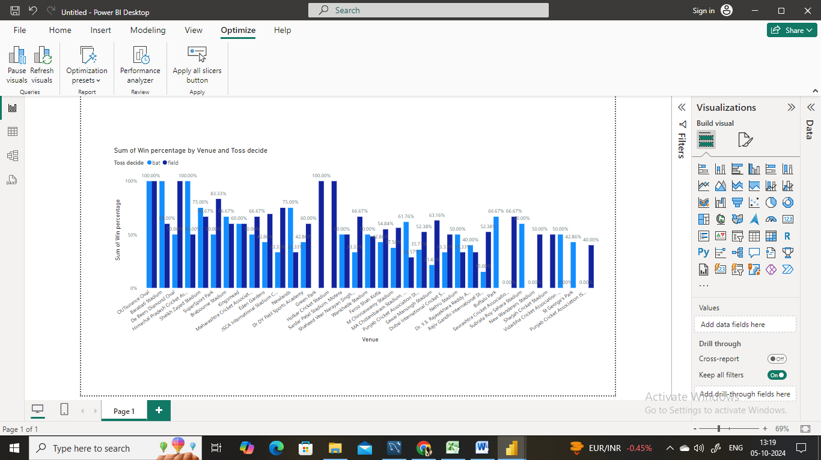

**2. Suggest some of the players who would be best fit for the team?**

**Ans.** On the basis of the performance of the players we can choose the players who would be the best fit.

While selecting the players we will analyse the performance on the basis of the average runs scored,

Batting average, their strike rate ,their bowling average, bowling strike rate etc.

Below mentioned tree map shows the top 20 players on the basis of their performance which is

being analysed on the above discussed criteria.

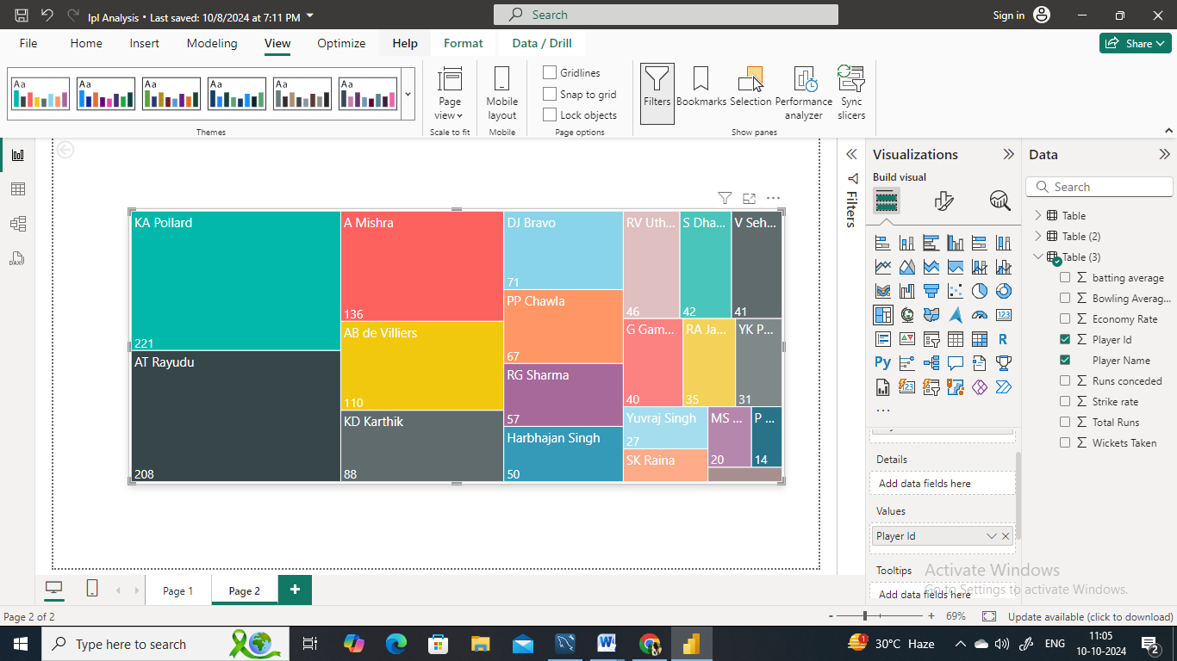

**3. What are some of parameters that should be focused while selecting the players?**

**Ans.** The following are some of the parameters that we should focus while selecting the players :

* **Batting Performance:**

**1) Total runs scored:** It is a direct measure of batsman productivity. The higher the runs, the valuable the batsman will be for his team. Consistent run-scorers are very valuable and can give good opening to its team.

**2) Batting Average :** The batting average indicates the consistency of a batsman. The higher batting average shows that the batsman scores more before getting out. For example if the batting average of a batsman is 100 it means they score 100 runs every time they bat before getting out.

**3) Strike rate:** The strike rate indicates the speed at which the batsman scores run. A higher strike rate indicates an aggressive and a high scoring player, who can be good performer in limited over match. The higher strike rate shows the effectiveness of a batsman in rotating the side and hitting the boundaries.

* **Bowling Performance:**

**1) Total wickets taken:** It indicates the bowler’s productivity. It shoes that the bowler is good in taking the wickets of the key players.

**2) Bowling Average:** The bowling average indicates the consistency of a bowler. It shows how much runs a bowlers concedes for each wicket taken. The lower bowling average indicates that bowler is not only taking the wickets but also concedes the fewer runs and this shows the bowlers efficiency.

**3) Economy Rate:** Economy rate indicates how many runs a bowler concedes per over. A bowler with a lower economy rate is much crucial in limited over match as he can keep check on the opposition’s run rate.

**4) Strike Rate:** The strike rate in bowling shoes how many deliveries it takes on an average to take a wicket. A lower strike rate indicates that a bowler takes wickets more frequently thus creating pressure on the opposition team.

**4. Which players offer versatility in their skills and can contribute effectively with both bat and ball? (can**

**you visualize the data for the same)**

**Ans:**

**Query:**

**SELECT p.Player_Name,**

**COUNT(DISTINCT m.Match_Id) AS Matches_Played,**

**ROUND(SUM(bs.Runs_Scored) * 1.0 / NULLIF(COUNT(DISTINCT CASE WHEN b.Striker= p.Player_Id THEN m.Match_Id END), 0), 2) AS Batting_Average,**

**COUNT(w.Player_Out) AS Wickets_Taken,**

**ROUND(SUM(CASE WHEN b.Bowler = p.Player_Id THEN bs.Runs_Scored ELSE 0 END) * 1.0 / NULLIF(COUNT(w.Player_Out), 0), 2) AS Bowling_Average,**

**ROUND(((SUM(bs.Runs_Scored) * 1.0 / NULLIF(COUNT(DISTINCT CASE WHEN b.Striker = p.Player_Id THEN m.Match_Id END), 0)) +**

**(COUNT(w.Player_Out) * 25.0 / NULLIF(COUNT(DISTINCT CASE WHEN b.Bowler= p.Player_Id THEN m.Match_Id END), 0))**

**), 2) AS All_Rounder_Score**

**FROM**

**player p**

**LEFT JOIN**

**ball_by_ball b ON p.Player_Id IN (b.Striker, b.Non_Striker, b.Bowler)**

**LEFT JOIN**

**batsman_scored bs ON b.Match_Id = bs.Match_Id AND b.Over_Id = bs.Over_Id AND b.Ball_Id = bs.Ball_Id**

**LEFT JOIN**

**wicket_taken w ON b.Match_Id = w.Match_Id AND b.Over_Id = w.Over_Id AND b.Ball_Id = w.Ball_Id**

**JOIN**

**matches m ON b.Match_Id = m.Match_Id**

**GROUP BY**

**p.Player_Id, p.Player_Name**

**HAVING**

**Matches_Played >= 20 AND Wickets_Taken >= 10 AND Batting_Average > 20**

**ORDER BY**

**All_Rounder_Score DESC0**

**LIMIT 20;**

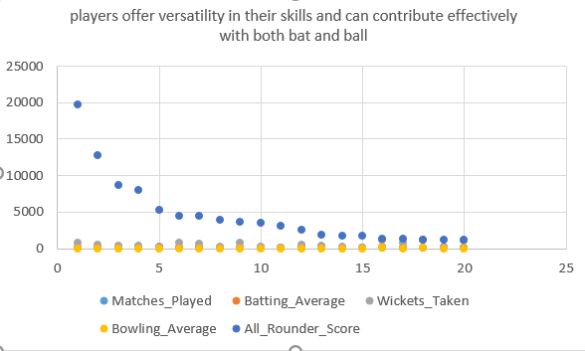

**5. Are there players whose presence positively influences the morale and performance of the team?**

**Ans.**  Yes, there are some players whose presence influences the morale and performance of the team.

**Query:**

**with player_matches as (select m.Match_Id, t.Team_Id, t.Team_Name,**

**p.Player_Id,p.Player_Name,m.Match_Winner,m.Win_Margin,   
 CASE WHEN w.Win_Type='runs' then 1 else 0 end as Won_Batting_First,**

**CASE WHEN w.Win_Type='wickets' then 1 else 0 end as Won_Bowling_First**

**from player_match pm**

**join player p on pm.Player_Id=p.Player_Id**

**join matches m on pm.Match_Id=m.Match_Id**

**join team t on t.Team_Id in (m.Team_1,m.Team_2)**

**join win_by w on w.Win_Id=m.Win_Type),**

**team_performance as (select pm1.Team_Id, pm1.Team_Name, pm1.Player_Id,pm1.Player_Name,**

**count(distinct pm1.Match_Id) as matches_played,**

**sum(case when pm1.Match_Winner =pm1.Team_Id then 1 else 0 END) AS Matches_Won,**

**avg(case when pm1.Match_Winner =pm1.Team_Id then pm1.Win_Margin else null end) as avg_win_margin,**

**sum(pm1.Won_Batting_First) as wins_batting_first, sum(pm1.Won_Bowling_First) as wins_bowling_first**

**from player_matches pm1**

**group by 1,2,3,4),**

**team_overall_performance as (select t1.Team_Id, count(distinct m1.Match_Id) as total_matches, sum(case when m1.Match_Winner=t1.Team_Id then 1 else 0 end) as total_wins**

**from matches m1**

**join team t1 on t1.Team_Id in (m1.Team_1,m1.Team_2)**

**group by t1.Team_Id)**

**SELECT tp.Team_Id,tp.Team_Name, tp.Player_Name, tp.matches_played,tp.Matches_Won,**

**round(tp.Matches_Won * 100.0/tp.matches_played,2) as win_percentage,**

**round(tp.avg_win_margin ,2) as avg_win_margin,tp.wins_batting_first,tp.wins_bowling_first,top.total_matches,top.total_wins,**

**round(top.total_wins * 100.0/top.total_matches, 2) as team_overall_win_percentage,**

**round((tp.Matches_Won * 100.0/tp.matches_played)-(top.total_wins * 100.0 /top.total_matches),2) as win_percentage_difference**

**from team_performance tp join team_overall_performance top on tp.Team_Id=top.Team_Id**

**where tp.matches_played >=10**

**order by win_percentage_difference desc, win_percentage desc**

**limit 20;**

The below given charts represents the win percentage when a player has played a match and overall team win percentage. Here we can see that those players when included in the team, then the winning percentage of a team increases that influences the morale and the performance of the team gets even more better.

**6. What would you suggest to RCB before going to mega auction ?**

Ans: Before going to mega auction I would like to suggest the RCB to look for the batsman who can perform well in death overs and focus on their strike rate .

In case when choosing for the bowlers the RCB should look for the bowlers whose economy rate is low as the lower economy rate indicate a bowler is more effective at preventing the opposing team from scoring the runs.

Not only batsman and bowlers the RCB should have at least 4 all rounders whose batting as well as bowling average is good and economy rate is also low.

The RCB should have experienced players as well as the younger players because the experience can be used in building the strategy to win the match and the young players have different bowling and batting style and have new strategy .

Also we see historically the RCB has always rely on the top order batsman and the middle order keep struggling under pressure. So RCB should strengthen his middle over. For this RCB should look for the players with the consistent batting average and strike rate under pressure.

We also see that the team often succeed in middle overs has effective spinners. So RCB should look for spinners who have a low economy rate in middle overs.

As per me , these are some of the important points that RCB should focus on before going to mega auction.

**7. What do you think could be the factors contributing to the high-scoring matches and the impact on**

**Viewership and team strategies.**

**Ans.** The factors contributing to high scoring matches are the power play runs and death over runs.

The team that scores high had a good start and comparatively score more runs in power play and also in the death overs.

**Query:**

**WITH match_scores AS (select m.Match_Id,t.Team_Name AS Batting_Team,SUM(bs.Runs_Scored) AS Total_Runs, v.Venue_Name,c.City_Name, co.Country_Name, td.Toss_Name, m.Season_Id, m.Outcome_type,**

**SUM(CASE WHEN b.Over_Id >= 16 THEN bs.Runs_Scored ELSE 0 END) AS Death_Over_Runs,**

**SUM(CASE WHEN b.Over_Id < 7 THEN bs.Runs_Scored ELSE 0 END) AS Powerplay_Runs**

**FROM matches m**

**join player_match pm on m.Match_Id=pm.Match_Id join ball_by_ball b on m.Match_Id=b.Match_Id**

**join batsman_scored bs on b.Match_Id=bs.Match_Id and b.Over_Id=bs.Over_Id and b.Ball_Id=bs.Ball_Id**

**join toss_decision td on td.Toss_Id=m.Toss_Winner**

**join team t on pm.Team_Id=t.Team_Id join venue v on m.Venue_Id=v.Venue_Id join city c on v.City_Id=c.City_Id**

**join country co on c.Country_id=co.Country_Id where bs.Runs_Scored is not null**

**group by m.Match_Id, t.Team_Name, v.Venue_Name, c.City_Name, co.Country_Name, td.Toss_Name, m.Season_Id, m.Outcome_type**

**having sum(bs.Runs_Scored) >300),**

**venue_analysis as**

**( select v.Venue_Name,c.City_Name, co.Country_Name, AVG(ms.Total_Runs) AS Avg_Runs,AVG(ms.Death_Over_Runs) AS Avg_Death_Over_Runs,**

**AVG(ms.Powerplay_Runs) AS Avg_Powerplay_Runs,**

**COUNT(ms.Match_Id) AS High_Scoring_Matches from match_scores ms join venue v on ms.Venue_Name=v.Venue_Name**

**join city c on c.City_Id=v.City_Id**

**join country co on c.Country_id=co.Country_id**

**group by v.Venue_Name,c.City_Name, co.Country_Name),**

**team_performance as**

**(select t.Team_Name,AVG(ms.Total_Runs) AS Avg_Team_Runs, AVG(ms.Death_Over_Runs) AS Avg_Team_Death_Over_Runs,**

**AVG(ms.Powerplay_Runs) AS Avg_Team_Powerplay_Runs, COUNT(ms.Match_Id) AS High_Scoring_Matches**

**from match_scores ms join team t on ms.Batting_Team=t.Team_Name**

**group by t.Team_Name)**

**select va.Venue_Name,**

**va.City_Name,va.Country_Name,va.Avg_Runs AS Avg_Venue_Runs,va.Avg_Death_Over_Runs AS Avg_Venue_Death_Over_Runs,**

**va.Avg_Powerplay_Runs AS Avg_Venue_Powerplay_Runs,va.High_Scoring_Matches AS High_Scoring_Matches_Venue,**

**tp.Team_Name,tp.Avg_Team_Runs AS Avg_Team_Runs,tp.Avg_Team_Death_Over_Runs AS Avg_Team_Death_Over_Runs,**

**tp.Avg_Team_Powerplay_Runs AS Avg_Team_Powerplay_Runs,tp.High_Scoring_Matches AS High_Scoring_Matches_Team**

**from venue_analysis va JOIN team_performance tp on tp.Avg_Team_Runs > 300**

**order by va.High_Scoring_Matches DESC,tp.Avg_Team_Runs DESC;**

**8. Analyze the impact of home ground advantage on team performance and identify strategies to**

**maximize this advantage for RCB.**

**Query:**

**with team_performance as (SELECT t.Team_Name,v.Venue_Name,m.Match_Id,SUM(bs.Runs_Scored) AS Total_Runs,COUNT(w.Player_Out) AS Wickets_Taken,**

**SUM(CASE WHEN b.Over_Id >= 16 THEN bs.Runs_Scored ELSE 0 END) * 6.0 / COUNT(CASE WHEN b.Over_Id >= 16 THEN 1 END) AS Death_Over_Economy,**

**case when v.Venue_Name='M Chinnaswamy Stadium' then 'Home' else 'Away' end as 'Ground_type',**

**case when m.Outcome_type=2 then 1 else 0 end as win**

**from matches m join player_match pm on m.Match_Id=pm.Match_id**

**join team t on pm.Team_Id=t.Team_Id**

**join ball_by_ball b on m.Match_Id = b.Match_Id**

**left join batsman_scored bs on b.Match_Id = bs.Match_Id AND b.Over_Id = bs.Over_Id AND b.Ball_Id = bs.Ball_Id**

**left join wicket_taken w on b.Match_Id = w.Match_Id AND b.Over_Id = w.Over_Id AND b.Ball_Id = w.Ball_Id**

**join venue v on m.Venue_Id=v.Venue_Id where t.Team_Name='Royal Challengers Bangalore' group by t.Team_Name,v.Venue_Name,m.Match_Id),**

**team_home_away_stats AS (**

**SELECT**

**Ground_Type,**

**COUNT(DISTINCT Match_Id) AS Matches_Played,**

**SUM(Win) AS Wins,**

**ROUND(SUM(Win) * 100.0 / COUNT(DISTINCT Match_Id), 2) AS Win_Percentage,**

**AVG(Total_Runs) AS Avg_Runs_Scored,**

**AVG(Wickets_Taken) AS Avg_Wickets_Taken,**

**ROUND(AVG(Death_Over_Economy), 2) AS Avg_Death_Over_Economy**

**FROM**

**team_performance**

**GROUP BY**

**Ground_Type)**

**SELECT**

**Ground_Type AS Venue_Type,**

**Matches_Played,**

**Wins,**

**Win_Percentage,**

**Avg_Runs_Scored,**

**Avg_Wickets_Taken,**

**Avg_Death_Over_Economy**

**FROM**

**team_home_away_stats;**

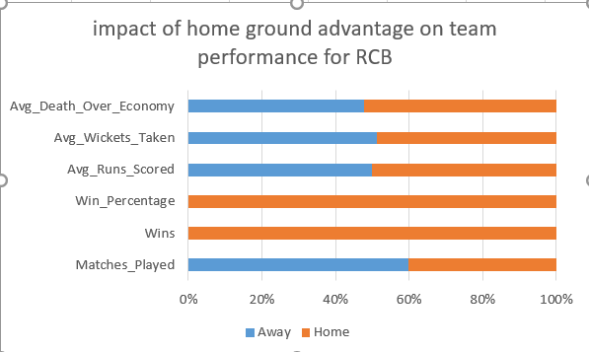

**9. Come up with a visual and analytical analysis with the RCB past seasons performance and potential**

**reasons for them not winning a trophy.**

**Ans.**

**Query:**

**WITH rcb_performance AS (**

**SELECT**

**m.Match_Id,**

**m.Season_Id,**

**m.Match_Winner,**

**SUM(CASE WHEN (m.Team_1 = 2 OR m.Team_2 = 2) AND b.Striker = 2 THEN bs.Runs_Scored ELSE 0 END) AS Runs_Scored,**

**SUM(CASE WHEN (m.Team_1 = 2 OR m.Team_2 = 2) AND b.Striker != 2 THEN bs.Runs_Scored ELSE 0 END) AS Runs_Conceded**

**FROM**

**matches m**

**JOIN**

**ball_by_ball b ON m.Match_Id = b.Match_Id**

**JOIN**

**batsman_scored bs ON b.Match_Id = bs.Match_Id AND b.Over_Id = bs.Over_Id AND b.Ball_Id = bs.Ball_Id**

**WHERE**

**m.Team_1 = 2 OR m.Team_2 = 2**

**GROUP BY**

**m.Match_Id, m.Season_Id, m.Match_Winner**

**)**

**SELECT**

**Season_Id,**

**COUNT(CASE WHEN Match_Winner = 2 THEN 1 END) AS Wins,**

**COUNT(CASE WHEN Match_Winner != 2 AND Match_Winner IS NOT NULL THEN 1 END) AS Losses,**

**ROUND(AVG(Runs_Scored), 2) AS Avg_Runs_Scored,**

**ROUND(AVG(Runs_Conceded), 2) AS Avg_Runs_Conceded**

**FROM**

**rcb_performance**

**GROUP BY**

**Season_Id**

**ORDER BY**

**Season_Id;**

RCB’s inability to win the IPL trophy stems from a combination of factors: over-reliance on key players, inconsistent bowling, particularly at the death, frequent middle-order collapses, and fielding lapses. Addressing these areas in the upcoming mega auction can provide them with a balanced team capable of finally lifting the trophy.

**10. How would you approach this problem, if the objective and subjective questions weren't given?**

**Ans.** Understand the data: First, I'd examine the database schema to understand what data is available.

This typically includes tables for matches, players, teams, ball-by-ball data, and possibly player

statistics

* Define key areas of analysis: Even without specific questions, we can identify important aspects of IPL analysis- Team performance, Player performance, Tournament trends, Match statistics, Advantages of home ground.
* Come up with some of the players who would be best fit for the team and some of parameters that should be focused while selecting the players
* Dive deeper into specific areas: Based on the initial findings, I'd dive deeper into interesting trends or patterns: 1) Team analysis: Performance over seasons, home vs away performance, player retention impact. 2) Player analysis: Consistency, performance in different phases of the game, impact players. 3) Match analysis: Factors affecting match outcomes (toss, venue, etc.), close matches. 4) Economic analysis: Player auction trends, team budget utilization.
* Visualization: Create visualizations to better understand and communicate findings: 1) Win-loss charts for teams. 2) Performance trend lines for players. 3) Heat maps for batting/bowling performances.
* Identify areas for further research: Based on the analysis, identify questions that require more in-depth investigation or additional data.

**11. In the "Match" table, some entries in the "Opponent_Team" column are incorrectly spelled as**

**"Delhi_Capitals" instead of "Delhi_Daredevils". Write an SQL query to replace all occurrences of**

**"Delhi_Capitals" with "Delhi_Daredevils".**

**Query:**

**update `Match `**

**Set Opponent_Team = 'Delhi_Daredevils'**

**where Opponent_Team = 'Delhi_Capitals';**

**select * from matches**

**where Opponent_Team = 'Delhi_Daredevils'**